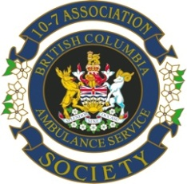

P R O X Y
As I cannot attend the 2018 AGM of the BCAS 10-7 Association to be held on June 5, 2018 in Sidney, BC
I, ___________________________________________________________________________
nominate: ___________________________________________________________________
to vote on my behalf as (s)he sees fit.
I certify that I am a member in good standing of the BCAS 10-7 Society.

____________________________________________________________________________
Signature Date

Send completed form to Vice President Fraser Field to be received prior to the meeting.

Fraser Field
VP, BCAS 10-7 Society
9629 Johnson Rd
Mission BC, V0M 1G0
fraser@canadiancoasters.ca

